**Experiment No:** 05

**Experiment Name:** Create a form using HTML.

**Theory:**

**Form:** An HTML form is a section of a web page that contains various elements such as input fields, buttons, checkboxes, radio buttons, and more, allowing users to submit data to a web server for processing.

**Input:** <input> tags are used to create various types of form controls that allow users to input data. The “type” attribute of the <input> tag determines the type of input control to be displayed, such as text input, checkboxes, radio buttons, and more.

**Basic Input types:**

❖ Text Input:

<input type=”text” />

❖ Email Input:

<input type=”email” />

❖ Password Input:

<input type=”password” />

❖ Text Area Input:

<textarea name=”details” />

❖ Radio Input:

<input type=”radio” name=”gender” value=”female” />

<input type=”radio” name=”gender” value”male” />

❖ Checkbox Input:

<input type=”checkbox” name=”terms-and-condition”/>

❖ Select and Options Input:

<select>

<option value=”autumn-2023”>Autumn 2023</option>

<option value=”spring-2024”> Spring 2024</option/>

<option value=”autumn-2024”>Autumn 2024</option>

</select>

❖ Form submit button:

<input type=”submit” value=”Login” />

**Lab Task - 1:** Make an HTML form to collect the information for admitting patients in a hospital.

**Source Code:**

<!DOCTYPE html>

<html lang="en">

  <head>

    <meta charset="UTF-8" />

    <meta name="viewport" content="width=device-width, initial-scale=1.0" />

    <title>Patient Admitting Form</title>

  </head>

   <body bgcolor="lightyellow">

    <center><h1><u><font color="blue">Patient Admitting Form</font></u></h1></center>

    <dd><label for="firstName"><b>First Name:</b></label>

        <input

          type="text"

          id="firstName"

          name="firstName"

          required

/><br /><br /></dd>

<dd><label for="lastName"><b>Last Name:</b></label><input type="text" id="lastName" name="lastName" required

/><br /><br />

        <dd><label for="Guardian Name"><b>Guardian Name:</b></label>

        <input type="text" id="Guardian Name" name="Guardian Name" required /><br /><br />

<label for="dob"><b>Date of Birth:</b></label>

 <input type="date" id="dob" name="dob" required

/><br /><br /></dd>

<dd><label for="gender"><b>Gender:</b></label>

        <select id="gender" name="gender" required>

          <option value="">Select</option>

          <option value="male">Male</option>

          <option value="female">Female</option>

          <option value="other">Other</option></select

        ><br /><br/></dd>

        <dd><label for="Blood Group"><b>Blood Group:</b></label>

        <select id="Blood Group" name="Blood Group" required>

          <option value="">Select</option>

          <option value="A+">A+</option>

          <option value="A-">A-</option>

          <option value="B+">B+</option>

          <option value="B-">B-</option>

          <option value="O+">O+</option>

          <option value="O-">O-</option>

          <option value="AB+">AB+</option>

          <option value="AB-">AB-</option>

</select>

<br /><br/></dd>

       <dd><label for="Marital Status"><b>Marital Status:</b></label>

        <select name="marital_status" id="marital_status">

    <option value="">Select</option>

    <option value="Single">Single</option>

    <option value="Married">Married</option>

    <option value="Widowed">Widowed</option>

    <option value="Divorced">Divorced</option>

</select>

<br/><br/></dd>

        <dd><label> <b>Phone Number :</b> </label>

      <input type="text" name="country code" value="+880" size="2"/>

      <input type="text" name="phone Number" size="10" /> <br />

<br/></dd>

    <dd><label><b>Guardian Phone Number: </b></label>

      <input type="text" name="country code" value="+880" size="2"/>

<input type="text" name=" Guardian phone Number" size="10" /> <br />

<br/></dd>

        <dd><label for="email"><b>Email Address:</b></label>

<input type="email" id="email" name="email" /><br /><br />

      </fieldset></dd>

       <dd><label for="address"><b>Address:</label><br />

        <textarea

          id="address"

          name="address"

          rows="4"

          cols="50"

          required></textarea>

<br /><br /></dd>

<dd><label for="city">City:</label>

        <input type="text" id="city" name="city"required/><br/><br/>

 <label for="medicalCondition"

          >Medical Condition/Reason for Admission:</label

        ><br />

        <textarea

          id="medicalCondition"

          name="medicalCondition"

          rows="4"

          cols="50"

          required

        ></textarea>

<br /><br /></dd>

<dd><label for="allergies">Allergies:</label><br />

        <textarea id="allergies" name="allergies" rows="3" cols="50"></textarea

        ><br /><br /></dd>

<dd><label for="existingConditions">Existing Medical Conditions:</label

        ><br />

        <textarea

          id="existingConditions"

          name="existingConditions"

          rows="4"

          cols="50"

        ></textarea

        ><br /><br /></dd>

<dd><label for="medications">Current Medications:</label><br/>

<textarea

          id="medications"

          name="medications"

          rows="3"

          cols="50"

        ></textarea

        ><br /><br />

      </fieldset></dd>

 <dd><legend><h3><font color="red">Emergency Contact Information:</font></h3></legend></dd>

<dd><label for="emergencyName">Name:</label>

        <input

          type="text"

          id="emergencyName"

          name="emergencyName"

          required

        /><br /><br /></dd>

<dd><label for="emergencyPhone">Phone Number:</label>

        <input

          type="tel"

          id="emergencyPhone"

          name="emergencyPhone"

          required

        /><br /><br /></dd>

<dd><label for="relationship">Relationship:</label>

        <input

          type="text"

          id="relationship"

          name="relationship"

          required

        /><br /><br />

      </dd>

      <dd><input type="file"></dd><br>

      <dd><input type="Submit">

 <input type="Reset"></dd>

</body>

</html>

**Output:**

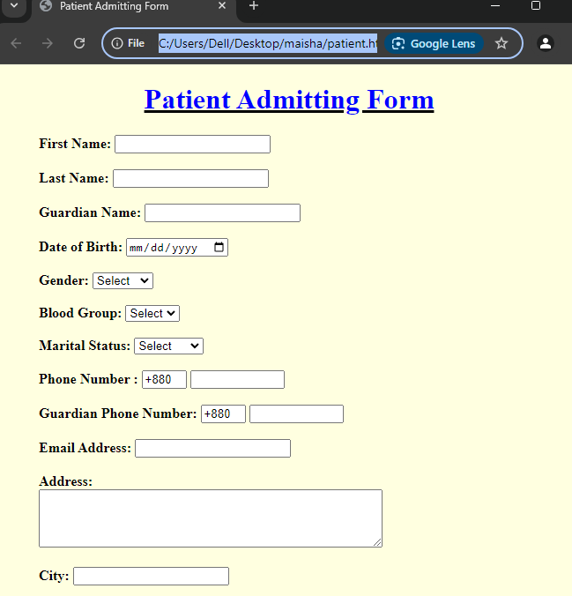

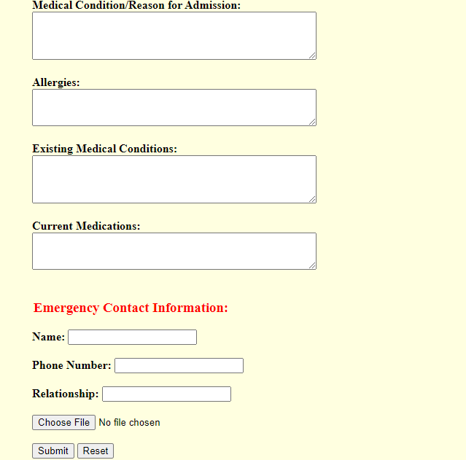

**Lab Task - 2:** Suppose you are a university teacher; a student wants to get admission to your university.Create a form by using HTML to collect necessary admission information from him.

**Source Code:**

<!DOCTYPE html>

<html lang="en">

  <head>

    <meta charset="UTF-8" />

    <meta name="viewport" content="width=device-width, initial-scale=1.0" />

    <title>University Admission Form</title>

  </head>

  <body bgcolor="lightblue">

<center><h1><u><font color="blue">University Admission Form</font></u></h1></center>

<dd><label for="firstName"><b>First Name:</b></label>

      <input type="text" id="firstName" name="firstName" required /><br /><br />

<label for="lastName"><b>Last Name:</b></label>

      <input type="text" id="lastName" name="lastName" required /><br /><br />

<label for="father'sname"><b>Father's Name:</b></label>

      <input type="text" id="father'sname" name="father'sname" required /><br /><br />

<label for="mother'sname"><b>Mother's Name:</b></label>

      <input type="text" id="mother'sname" name="mother'sname" required /><br/><br/>

<label for="dob"><b>Date of Birth:</b></label>

      <input type="date" id="dob" name="dob" required /><br /><br />

      <label for="religion"><b>Religion:</b></label>

      <input type="religion" id="religion" name="religon" required /><br /><br />

      <label for="gender"><b>Gender:</b></label>

        <select id="gender" name="gender" required>

          <option value="">Select</option>

          <option value="male">Male</option>

          <option value="female">Female</option>

          <option value="other">Other</option></select

        ><br /><br/>

      <label for="Blood Group"><b>Blood Group:</b></label>

        <select id="Blood Group" name="Blood Group" required>

          <option>Select</option>

          <option value="A+">A+</option>

          <option value="A-">A-</option>

          <option value="B+">B+</option>

          <option value="B-">B-</option>

          <option value="O+">O+</option>

          <option value="O-">O-</option>

          <option value="AB+">AB+</option>

          <option value="AB-">AB-</option>

</select>

        <br /><br/>

       <label for="Marital Status"><b>Marital Status:</b></label>

        <select name="marital_status" id="marital_status">

    <option value="">Select</option>

    <option value="Single"><b>Single</b></option>

    <option value="Married"><b>Married</b></option>

</select><br/><br/>

<label for="present address"><b>Present Address:</b></label><br />

      <textarea

        id="presentaddress"

        name="presentaddress"

        rows="2"

        cols="40"

        required></textarea>

        <br /><br />

<label><b>City:</b></label>

<input type="text"><br/><br/>

<label><b>Post code:</b></label>

<input type="number"> <br/><br/>

        <label> <b>Phone Number :</b> </label>

      <input type="text" name="country code" value="+880" size="2" />

      <input type="text" name="phone Number" size="10" /> <br />

    <br/>

<label for="email"><b>Email:</b></label>

      <input type="email" id="email" name="email" required /><br /><br /></dd>

<dd><label for="course"><b>Select Course:</b></label>

          <select id="course" name="course" required>

         <option value="">Select</option>

            <option value="computerScience&engineering">Computer Science & Engineering</option>

            <option value="computer&communicationengineering">Computer & Communication Engineering</option>

            <option value="electrical&electronicengineering">Electrical & Electronics Engineering</option>

            <option value="mechanicalEngineering">

              Mechanical Engineering</option>

 <option value="businessManagement">Business Management</option>

      <option value="Law">Law</option>

              <option value="english">English</option>

    </select><br/><br/></dd>

   <dd><label><b>Admission Type:</b></label><br>

<select>

    <option>Select</option>

    <option>International Student</option>

      <option>Domestic Transfer Student</option>

    <option>Change of Status</option>

</select><br><br>

<lable><b>Copies of your High school record</b></lable><br>

<input type="file"><br><br>

<lable><b>Official Transcripts from all college/Universities attended </b></lable><br>

    <input type="file"><br><br></dd>

<label>

           <dd><input type="checkbox" name="declaration" required > I hereby

            declare that the above information is true and correct.

          </label><br/><br/></dd>

        <dd><input type="Submit">

 <input type="Reset"></dd>

    </form>

</body>

</html>

**Output:**

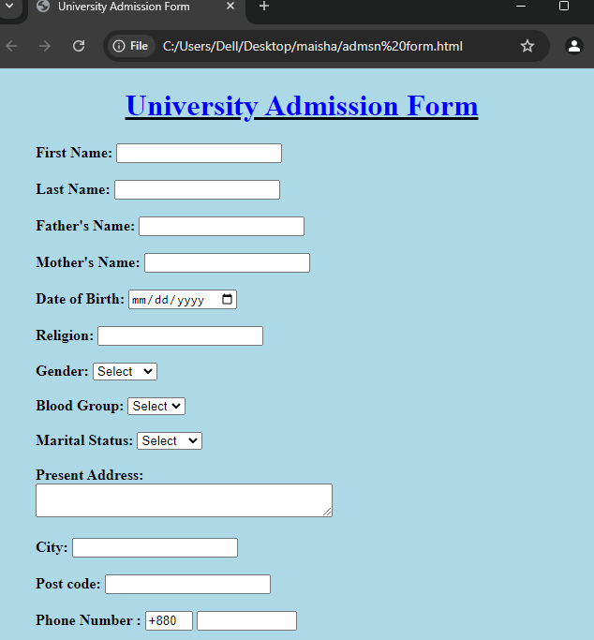

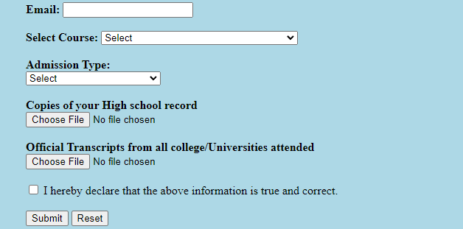

**Discussion:** In today’s lab, we got knew about how to create a form by using HTML. An HTML form is a section of a web page that contains various elements such as input fields,buttons, checkboxes, radio buttons, and more, allowing users to submit data to a web server for processing.in our experiment we created two form one is hospital admitting form and another is university admission form. By using varoius tags like <label>,< select>,<option> etc we completed our lab tasks.

**Experiment No:** 06

**Experiment Name:** Introduction to HTML multimedia tags:

A. Create a section to display images using <img> tag

B. Create a section to play video files using <video> tag

C. Create a section to play audio files using <audio> tag

D. Create a section to display another webpage content / YouTube content using <iframe> tag .

**Theory:** HTML multimedia tags are used to embed and manage various types of media content like images, audio, and video on web pages. These tags include `*<img>*` for images, `*<audio>*` for sound, and `*<video>*` for video playback, providing seamless integration of multimedia elements. With attributes such as controls, autoplay, and source options, these tags allow developers to customize the user experience. They play a key role in creating interactive, dynamic, and engaging websites.

**Lab Task:** Create a simple website with 4 pages, each using a different HTML file: "image.html", "video.html", "audio.html", and "iframe.html". Add a header on each page with links so you can easily navigate between pages by clicking the links.

1. **Index.html (Home Page):**

**Source Code:**

<!DOCTYPE html>

<html>

  <head>

  <title>Simple Website</title>

  </head>

  <body>

  <header>

  <nav>

  <a href="image.html">Image</a> , <a href="video.html">Video</a> ,

  <a href="audio.html">Audio</a> , <a href="iframe.html">Iframe</a> .

  </nav></header>

  <body style="text-align:center">

  <h1>Welcome to my Simple Website</h1>

  </body>

</html>

**Output:**

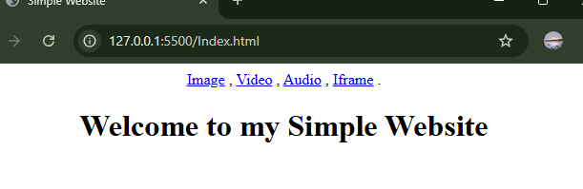)

1. **Image Page (Image.html):**

**Source Code:**

<!DOCTYPE html>

<html lang="en">

<head>

<meta charset="UTF-8" />

<meta name="viewport" content="width=device-width, initial-scale=1.0" />

<title>Image Page</title>

</head>

<header>

<nav>

<a href="index.html">Home</a> , <a href="video.html">Video</a> ,

<a href="audio.html">Audio</a> , <a href="iframe.html">Iframe</a> .

</nav>

</header>

<body style="text-align: center">

<h1>Image Page</h1>

<img src="nature 2.jpg" height="350" width="450" />

</body>

</html>

**Output:**

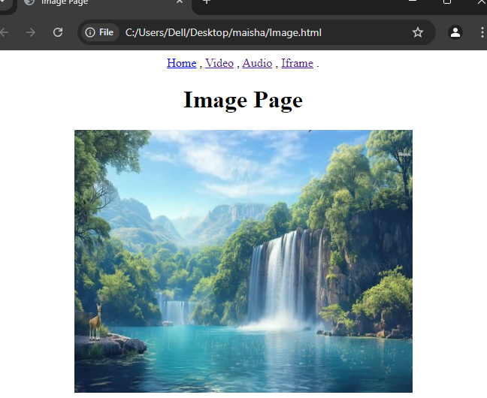

1. **Video Page (Video.html):**

**Source Code:**

<!DOCTYPE html>

<html lang="en">

  <head>

    <meta charset="UTF-8" />

    <meta name="viewport" content="width=device-width, initial-scale=1.0" />

    <title>video page</title>

  </head>

  <header>

    <nav>

      <a href="index.html">Home</a> , <a href="image.html">Image</a> ,

      <a href="audio.html">Audio</a> , <a href="iframe.html">Iframe</a> .

    </nav>

  </header>

  <body style="text-align: center">

    <h1>Video Page</h1>

    <video width="600px" height="400px" controls="controls">

      <source src="cat video.mp4" type="video/mp4" />

    </video>

  </body>

</html>

**Output:**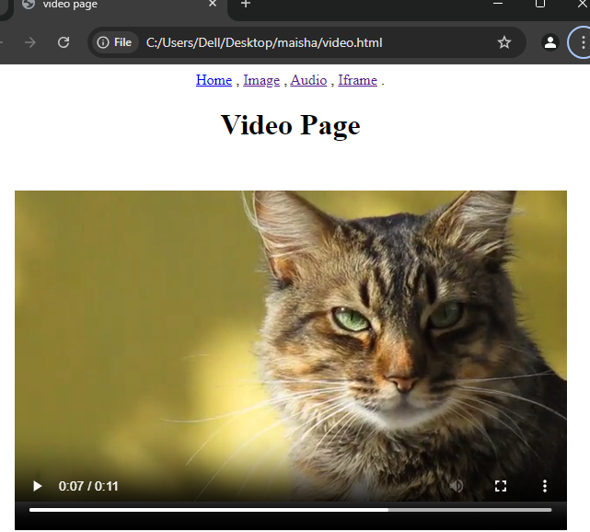

1. **Audio Page (Audio.html):**

**Source Code:**

<!DOCTYPE html>

<html lang="en">

  <head>

    <meta charset="UTF-8" />

    <meta name="viewport" content="width=device-width, initial-scale=1.0" />

    <title>Audio Page</title>

  </head>

  <header>

    <nav>

      <a href="index.html">Home</a> ,<a href="image.html">Image</a> ,

      <a href="video.html">Video</a> ,<a href="iframe.html">Iframe</a> .

    </nav>

  </header>

  <body style="text-align: center">

    <dd>

      <h1>Audio Page</h1>

    </dd>

      <dd>

        <audio controls>

          <source src="audio.mp3" type="audio/mp3" />

        </audio>

      </dd>

  <dd>

    <audio controls>

      <source src="audio 2.mp3" type="audio/mp3" />

    </audio>

</dd>

  </body>

</html>

**Output:**

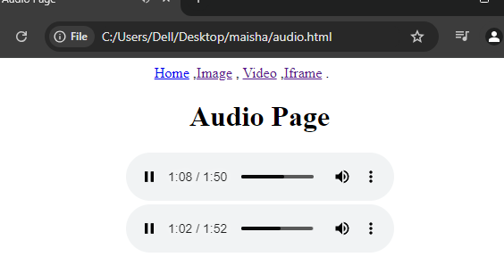

1. **Iframe Page (Iframe.html):**

**Source Code:**

<!DOCTYPE html>

<html lang="en">

 <head>

 <meta charset="UTF-8" />

<meta name="viewport" content="width=device-width, initial-scale=1.0" />

<title>Iframe Page</title>

</head>

  <header><nav>

   <a href="index.html">Home</a> , <a href="image.html">Image</a> ,

   <a href="video.html">Video</a> , <a href="audio.html">Audio</a> .

    </nav></header>

  <body style="text-align: center">

  <h1>Iframe Page</h1>

  <iframe

  width="560"

  height="315"

  src="https://www.youtube.com/embed/Cn4G2lZ_g2I?si=cwoiPFGANsEK4-QA "title="YouTube video player” frameborder="0"allow="accelerometer; autoplay; clipboard-write; encrypted-media; gyroscope; picture-in-picture; web-share" referrerpolicy="strict-origin-when-cross-origin" allowfullscreen > </iframe>

  </body>

</html>

**Output:**

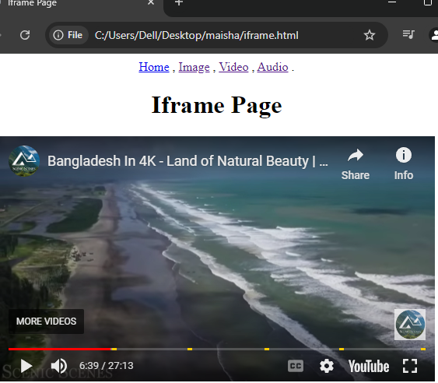

**Discussion:** In today’s lab, we got knew about how to create types of media content like images, audio, and video on web pages by using HTML.HTML multimedia tags are used to embed and manage various types of media content like images, audio, and video on web pages. These tags include `*<img>*` for images, `*<audio>*` for sound, and `*<video>*` for video playback, providing seamless integration of multimedia elements. With attributes such as controls, autoplay, and source options, these tags allow developers to customize the user experience.By using necessary tags we completed our lab tasks.